**Mechanics Laboratory**

**Measurement of Vehicle Motion**

18 January 2019

Fitzwilliam College

Louis Zeng (lz406, Lab Group 94)

Car No. 7

Figure 1

(Experiment setup & Examine data output)

•IMU measures accelerations and yaw velocity at car’s centre line.

•Rotary encoder count rotation of LH wheel. (may travel different distance than IMU)

•Recording data while car stationary.

•Acceleration data from IMU is non-zero while stationary, due to indirect measuring method.

Q1a•10 recorded data point every 0.5 second, sampling rate is at 20Hz.

Q1B•

|  |  |  |  |  |
| --- | --- | --- | --- | --- |
|  | Lateral acceleration | Wheel encoder | Yaw velocity | Longitudinal acceleration |
| Quantization step size | 0.01m/s^2 | 0 | 0.001rad/s | 0.01m/s^2 |
| Mean value | 0.72m/s^2 | 0 | 0 | 0.05m/s^2 |
| Consist with expectation? | N | Y. wheels kept stationary | Y. no yawing | N. car keep stationary |
| Peak-to-peak | 0.05m/s^2 | 0 | 0 | 0.02m/s^2 |
| Consist with expectation? | N. car keep stationary | Y. wheels kept stationary | Y. no yawing | N. car keep stationary |

Figure 2

(Calibrate rotary encoder before the experiment)

•Tape measured distance should agree with encoder measurement if ‘wheeldia’ is accurate.

Q2 • ‘wheeldia’=0.0383m, is consistent with tape measure.

• When encoder is properly calibrated, its distance reading agrees with actual measurement.

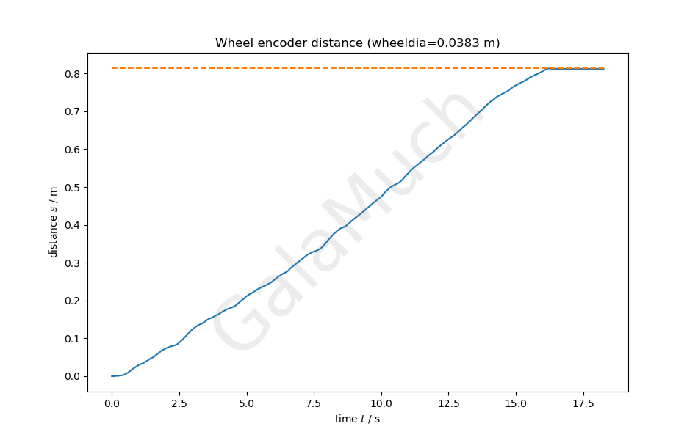

Figure 3

(distance measurement⎯direct encoder reading vs IMU acceleration integration)

•Wheel slipping causes encoder measurement inaccurate.

•Distance be estimated by integrate twice the IMU longitudinal acceleration reading.

•Encoder distance reading can be differentiated, gives velocity, acceleration values for comparison.

•Acceleration, velocity and distance determined from 2 methods get compared.

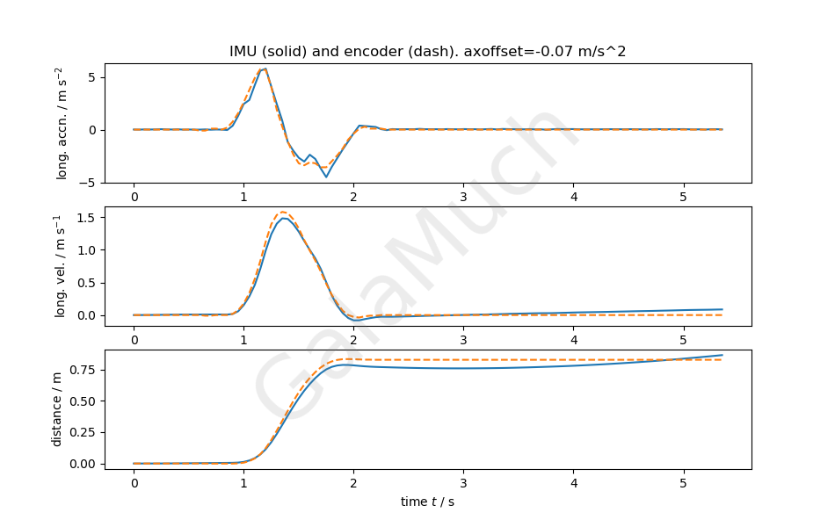

Q3 a•Data agree with expectation. Discrepancies caused by IMU and encoder located different parts, travel separate paths.

• No-zero IMU acceleration reading while car stops make IMU velocity reading non-zero when stopped.

Q3 b• Offset value = -0.07 m/s^2.

•Completely eliminate drift in acceleration reading, small discrepancies still exist for determined velocity and displacement.

Figure 4

(Calibrate IMU yaw velocity reading)

•Integrate yaw velocity get yaw angle.

•Compare calculated yaw angle with actual measurement, therefore calibrate the former.

•Double check encoder distance reading is reliable through radius measurement.

Q4• Tape measured radius = 0.31m, calculated radius = 0.3035m

Consistent values.

•Small discrepancy caused by encoder measures LH rear wheel and imperfect circular path.

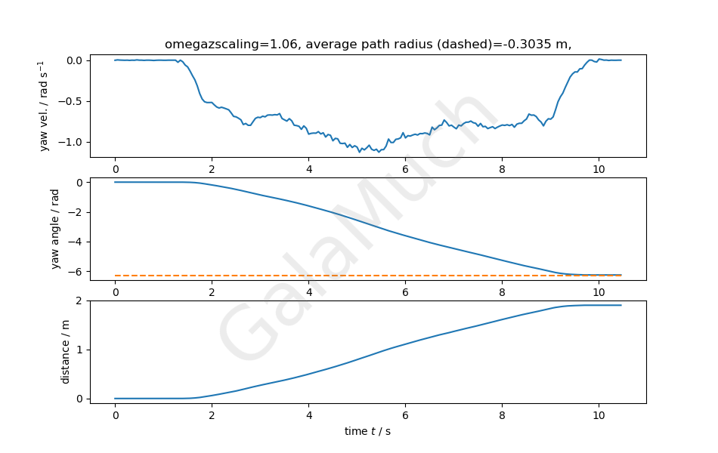

Figure 5

(Estimate radius of path through ***r* = *vx / ωz*** )

•Differentiating displacement reading from encoder, obtain longitudinal velocity.

•Longitudinal velocity divide by IMU yaw velocity, determine path radius.

Q5• path radius calculated through ***r* = *vx / ωz*** concur Q4 result, discrepancy only appear when the vehicle doesn’t move.

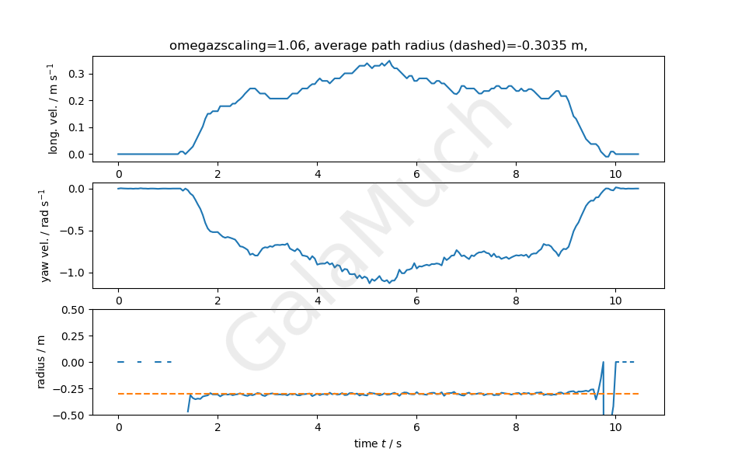

Figure 6

(Estimate radius of path through *r* = *vx /ay* )

•Longitudinal velocity Vx is determined from the encoder output, lateral acceleration from the IMU reading.

•Compare the results with Figure 4 in order to justify the method.

Q6• average value of radius calculated through this method consistent with 4.1.

• Noise from IMU lateral acceleration reading results in large fluctuations on calculated radius.

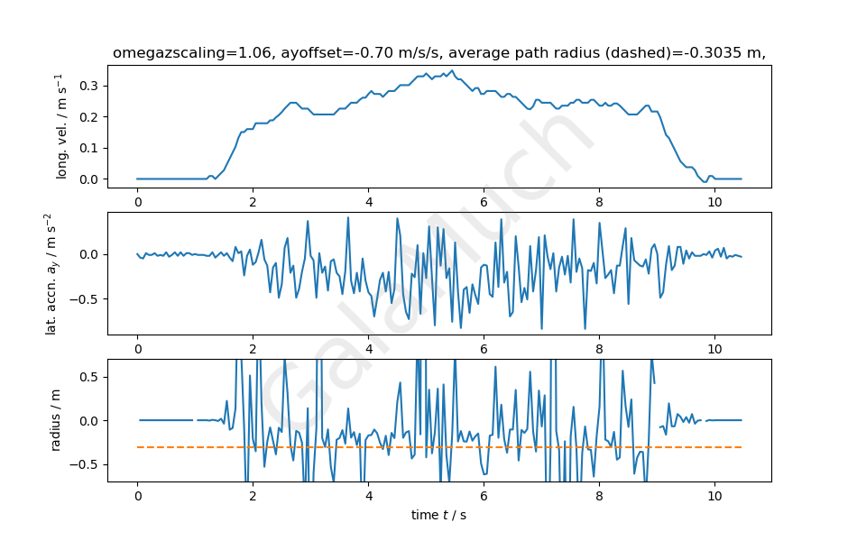

Figure 7

(Calibrate IMU again before Estimating radius of path through *r* = *vx/ ωz* )

•Longitudinal velocity Vx is determined from the encoder output, lateral acceleration from the IMU reading.

Q7•Acoffset used = -0.03m/s/s different from value used in Q3b (-0.07).

•Noise in acceleration reading might cause offset discrepancy.

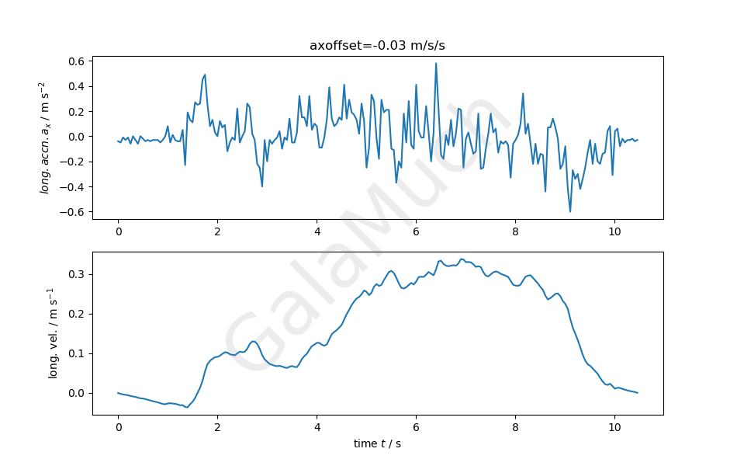

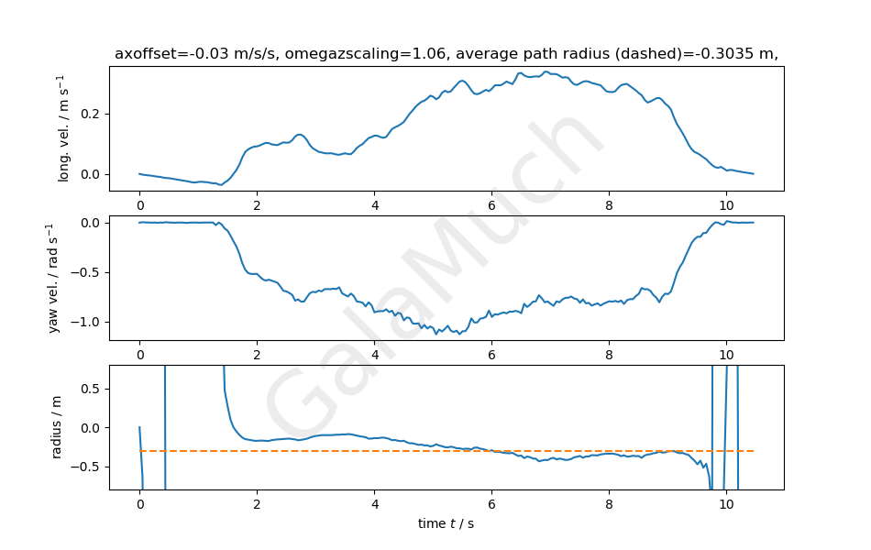Figure 8

(Estimating radius of path through *r* = *vx/ ωz*)

•Longitudinal velocity Vx is from twice integration of IMU longitudinal acceleration, yaw velocity is directly from IMU reading.

•Make comparison with previous radius result in order to certify the method.

Q8•Whole time history of calculated radius roughly consistent with previous result.

•Longitudinal centreline where IMU located has less radius than LH wheel where encoder is, smaller radius plotted on the graph.

Figure 9

(Travel arbitrary path ⎯ final confirmation of measured data)

•Using wheel encoder data and yaw velocity, in order to avoid integration offset error.

•Start and stop the car at the same position, increment in displacement should return to zero.

•Plotting path of the car to confirm expectation.

Q9 • Graph concur with expectation. Green and red circle roughly coincide. (indicating start/end of the path respectively)

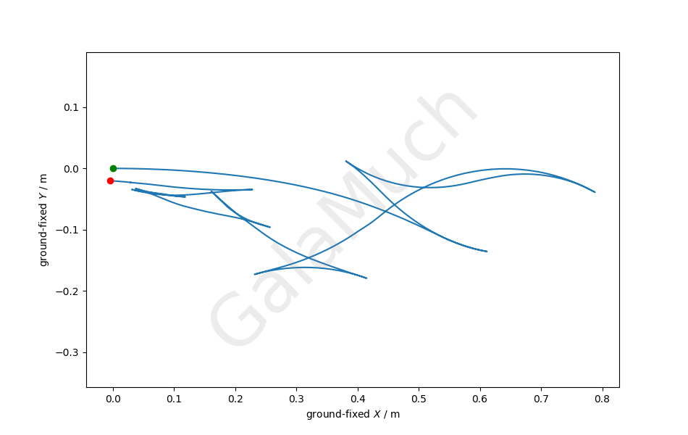•X and Y displacements return to (0,0)

Q9b•Encoder signal + acceleration signals from IMU or acceleration and deduced velocity/displacement reading from IMU.

• Other methods will have worse accuracy due to IMU output noise and integration offset.